**PES UNIVERSITY**



A Project Report on

***“Design and Analysis of a Pyramidal Horn Antenna for a fixed gain***

Submitted by:

|  |  |
| --- | --- |
| PES2UG20EC004 | Aasil Malik Shaik |
| PES2UG20EC047 | Manoj Kumar CM |
| PES2UG20EC049 | Mohammed Muzammil |
| PES2UG20EC051 | Mrudulla M |

Under the guidance of:

**Prof. Shreyus Gautham Kumar**

**Assistant Professor,**

**Department of Electronics and Communication Engineering**

**PES UNIVERSITY**

Electronic City, Bangalore-560100

2023



**ABSTRACT**

**Abstract:** The horn antenna has a specific level of gain that cannot be adjusted, and its performance can be optimised by finding the flare angle at the optimum length of the antenna. The flare angle is the angle between the walls of the horn antenna and the central axis of the antenna.

To find the flare angle at the optimum length of the horn antenna, various techniques can be used, including numerical simulations, experimental measurements, and analytical methods. Numerical simulations involve using software tools to simulate the behaviour of the horn antenna and determine the flare angle at the optimum length.

The optimisation of the flare angle at the optimum length of a horn antenna is crucial to ensure that the antenna radiates the maximum amount of energy in the desired direction.

**Keywords:** Antenna gain, Flare angle, maximum phase error, optimum length



**TABLE OF CONTENTS**

|  |  |
| --- | --- |
| **CHAPTER NO** | **TITLE** |
| **1.** | **INTRODUCTION**   * 1. BACKGROUND   2. MOTIVATION   3. OBJECTIVE |
| **2.** | **METHODOLOGY** |
| **3.** | **IMPLEMENTATION** |
| **4.** | **CODE AND RESULT** |
| **5.** | **CONCLUSION** |



**CHAPTER 1**

**INTRODUCTION**

**Background**

Horn antennas are widely used in microwave and millimeter-wave applications due to their high gain, wide bandwidth, and low loss. They are commonly used in radar systems, satellite

communications, wireless communication systems, and scientific research.

**Motivation**

The main motivation for designing a horn antenna in MATLAB is to have a tool that can accurately design and optimize a horn antenna to meet the specific requirements of a particular application. MATLAB provides a powerful platform for antenna design and simulation, with a rich set of functions and tools that can be used to generate and analyze horn antennas.

**Objective**

The objective of designing a horn antenna in MATLAB is to obtain an optimized antenna design that meets the desired performance criteria, such as high gain, wide bandwidth, and low loss. By using MATLAB's simulation capabilities, the designer can optimize the horn antenna's dimensions and shape to achieve the desired radiation pattern, gain, and impedance matching. This approach can reduce the time and cost required for the antenna design process, as well as improve the overall performance of the antenna



**CHAPTER 2**

**METHODOLOGY**

Designing a horn antenna in MATLAB involves the following steps:

* Determine the desired operating frequency and the gain required for the application.
* Determine the type of horn antenna required based on the desired beamwidth and polarization. The most common types are pyramidal, conical, and sectoral.
* Calculate the dimensions of the horn antenna using empirical formulas.
* Create a MATLAB script or function to implement the calculations and generate the horn antenna geometry.
* Simulate the horn antenna using MATLAB's antenna toolbox or a third-party software to optimize the design for the desired gain, bandwidth, and radiation pattern.
* Fabricate the physical antenna using the optimized dimensions and test it for its performance characteristics such as gain, bandwidth, and efficiency.



**CHAPTER 3**

**IMPLEMENTATION**

* Determine the desired operating frequency and the gain required for the application.
* This step involves identifying the frequency range over which the antenna will operate, and the minimum gain required for the application. This information is necessary to determine the horn dimensions.
* Determine the type of horn antenna required based on the desired beamwidth and polarization.
* The horn antenna's type will depend on the desired beamwidth and polarization. For example, a pyramidal horn antenna is suitable for wide-angle radiation patterns, while a conical horn antenna is suitable for narrow-angle radiation patterns.
* Calculate the dimensions of the horn antenna using mathematical formulas or numerical methods such as the Finite Element Method (FEM) or Method of Moments (MoM).
* The horn dimensions can be calculated using mathematical formulas or numerical methods such as FEM or MoM. The horn dimensions will depend on the desired operating frequency, gain, and beamwidth. For example, the length and aperture width of a pyramidal horn antenna can be calculated using the following formulas:
* L = 0.5*lambda % Length of the horn a = 0.25*lambda/sin(theta_f*pi/180) % Aperture width of the horn
* where lambda is the wavelength of the signal, and theta_f is the flare angle of the horn.
* Create a MATLAB script or function to implement the calculations and generate the horn antenna geometry.
* The MATLAB script or function should implement the calculations and generate the horn antenna's geometry based on the dimensions calculated in step 3. The geometry can be generated using the MATLAB's built-in geometry functions, such as the rectangle function, or by creating a custom MATLAB function that defines the horn geometry.
* Simulate the horn antenna using MATLAB's antenna toolbox or a third-party software to optimize the design for the desired gain, bandwidth, and radiation pattern.
* Once the horn geometry is generated, it can be simulated using MATLAB's antenna toolbox or a third-party software to optimize the design for the desired gain, bandwidth, and radiation pattern. The simulation will help determine the best dimensions for the horn antenna to meet the desired performance criteria.
* Fabricate the physical antenna using the optimized dimensions and test it for its performance characteristics such as gain, bandwidth, and efficiency.
* After optimizing the design using simulation, the horn antenna can be fabricated using the optimized dimensions. The fabricated antenna should be tested to verify its performance
* characteristics such as gain, bandwidth, and efficiency. Testing can be done using a vector network analyzer (VNA) or other suitable equipment.

In summary, designing a horn antenna in MATLAB involves determining the operating frequency and gain required for the application, calculating the horn dimensions, generating the horn geometry, simulating the horn antenna to optimize the design, fabricating the physical antenna using the optimized dimensions, and testing the antenna for its performance characteristics.



**CHAPTER 4**

**CODE**

f=input("Enter the frequency ");

D=input("Enter the Directivity of the Antenna in dB:");

d=10^(D/10);

% Since the losses in the horn are negligible,we can assume the gain of

% the horn to be the same as the directivity.

G=d; % Gain of Horn Antenna

aw=input("Enter the Height of waveGuide:");

bw=input("Enter the width of waveGuide:");

AspectRatio=input("Enter the aspect ratio a/b :");

% To calculate the wavelength

c = 3*(10^(8));

lambda = c/f;

% To calculate a , b : Height and width of apperture of Horn Antenna

ab=(G*((lambda)^2))/(0.5*4*pi);

a=sqrt(ab*AspectRatio);

b=a/AspectRatio;

% To calculate rox,roy

% The optimum flare angle is different in the E and H planes because the amplitude distributions are different.

% In the H-plane the optimum flare angle is obtained when the maximum phase error (at the edge of the aperture

% in the H-plane) is equal to 3π/4 and in the E-plane it occurs when the maximum phase error is π/2.

% MPH max phase error H plane for rox , MPE max phase error E plane for roy

MPH=(3*pi)/4;

MPE=pi/2;

k=(2*pi)/lambda;

rox=(((0.5*a)^2)-((MPH/k)^2))/(2*(MPH/k));

roy=(((0.5*b)^2)-((MPE/k)^2))/(2*(MPE/k));

% To calculate Flare Angle

psiH=2*atan(sqrt((3*lambda)/(4*rox)));

psiE=2*atan(sqrt((lambda)/(2*roy)));

% To calculate length of Horn Antenna , consider Maximum of L1 and L2.

% recalculate psiH and psiE.

L1=(a-aw)/(2*tan(psiH/2));

L2=(b-bw)/(2*tan(psiE/2));

L=max(L1,L2);

psiH=2*atan((a-aw)/(2*L));

psiH=psiH*(180/pi);

psiE=2*atan((b-bw)/(2*L));

psiE=psiE*(180/pi);

disp("Horn Antenna Gain:")

disp(G)

disp("Parameters of Horn Antenna:")

disp("Height and width of apperture of Horn Antenna in m")

A=[a b];

disp(A)

disp("rox")

disp(rox)

disp("roy")

disp(roy)

disp("Length of Horn Antenna:")

disp(L)

disp("Flare Angles:")

disp("psiH")

disp(psiH)

disp("psiE")

disp(psiE)

Lw = 0.05; % length of waveguide

FO=[0.01 0];

% to show Horn Antenna

ant1 = horn('FlareLength',L,'FlareWidth',b,'FlareHeight',a,'Length',Lw,...

'Width',bw,'Height',aw,'FeedOffset',FO);

figure(1)

show(ant1);

% to show current distribution

figure(2)

current(ant1,f)

% to show impedance of Horn Antenna

figure(3)

freqRange = (8100:90:9900)*1e6;

impedance(ant1,freqRange)

% to show radiation pattern

figure(4)

pattern(ant1,f)

% to show elevation pattern

figure(5)

patternElevation(ant1,f)

%to show Azimuthal pattern

figure(6)

patternAzimuth(ant1,f)



**RESULTS**

1. **Structure of Horn Antenna Simulated.**

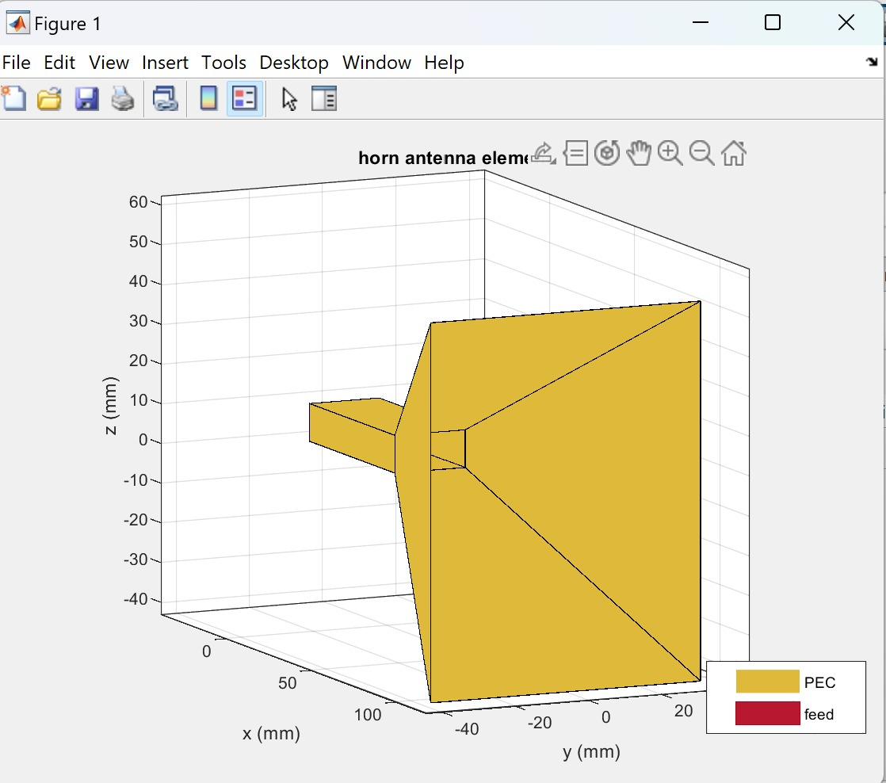



1. **Current Distribution**

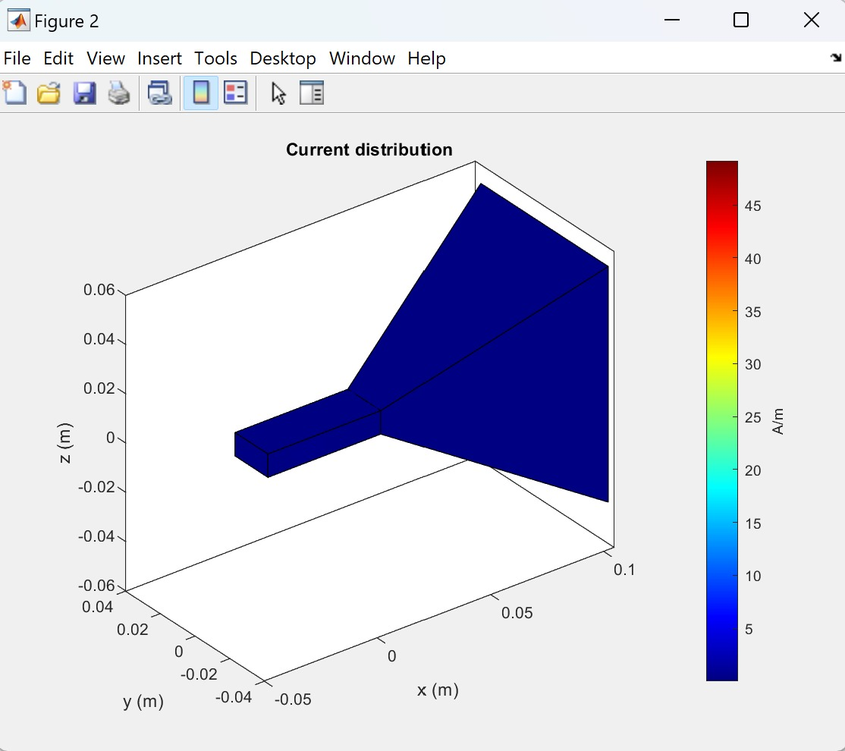



1. **Impedance vs Frequency**

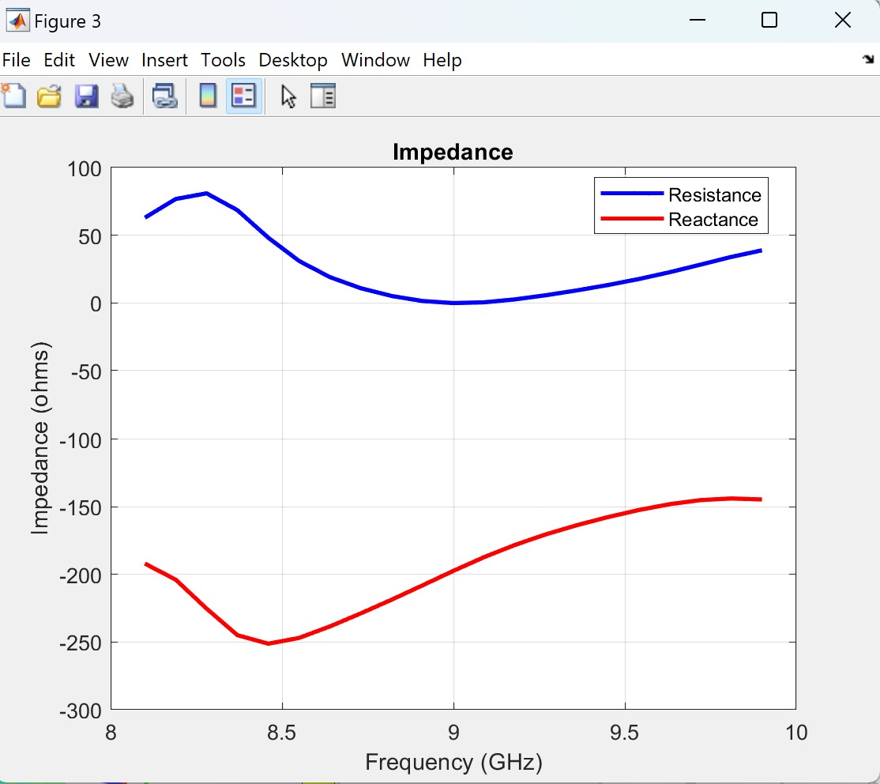



1. **Radiation pattern**

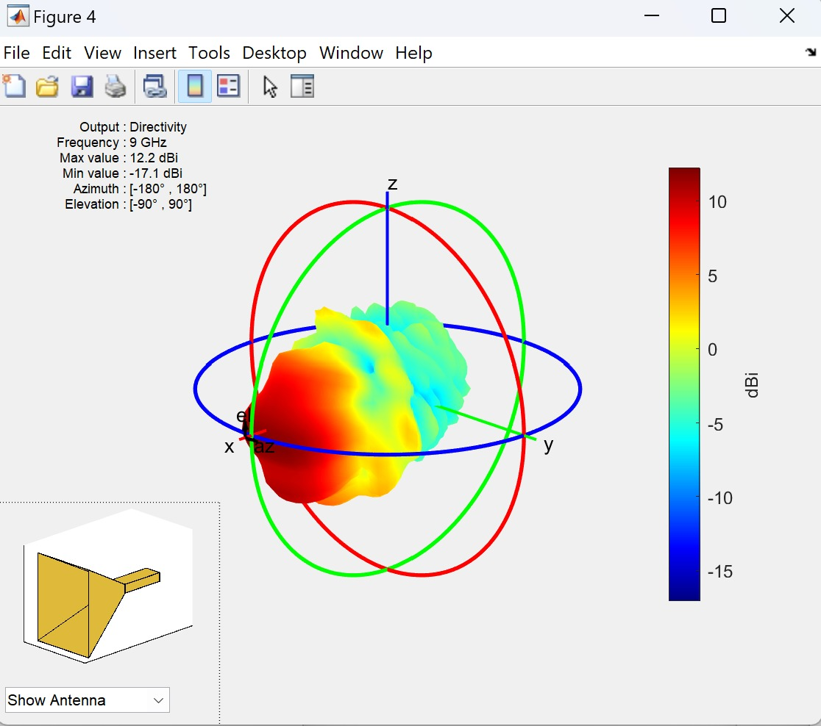



1. **Elevation pattern**

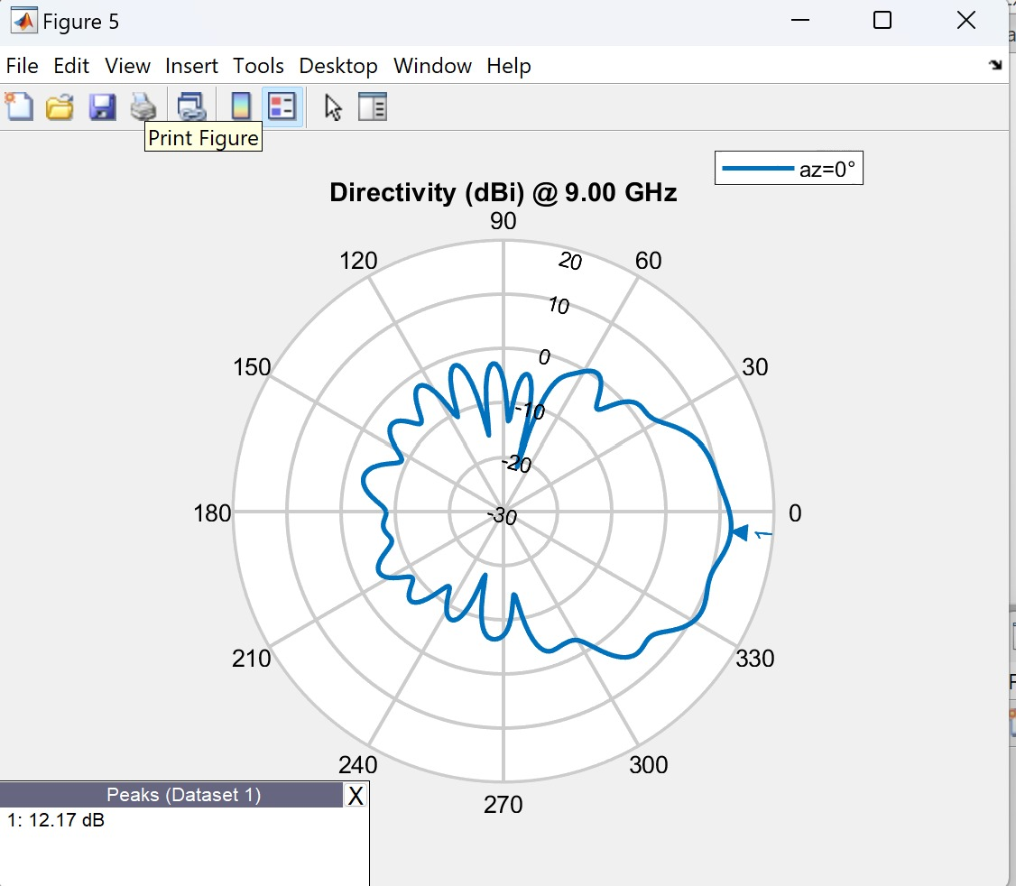



1. **Azimuthal Pattern**

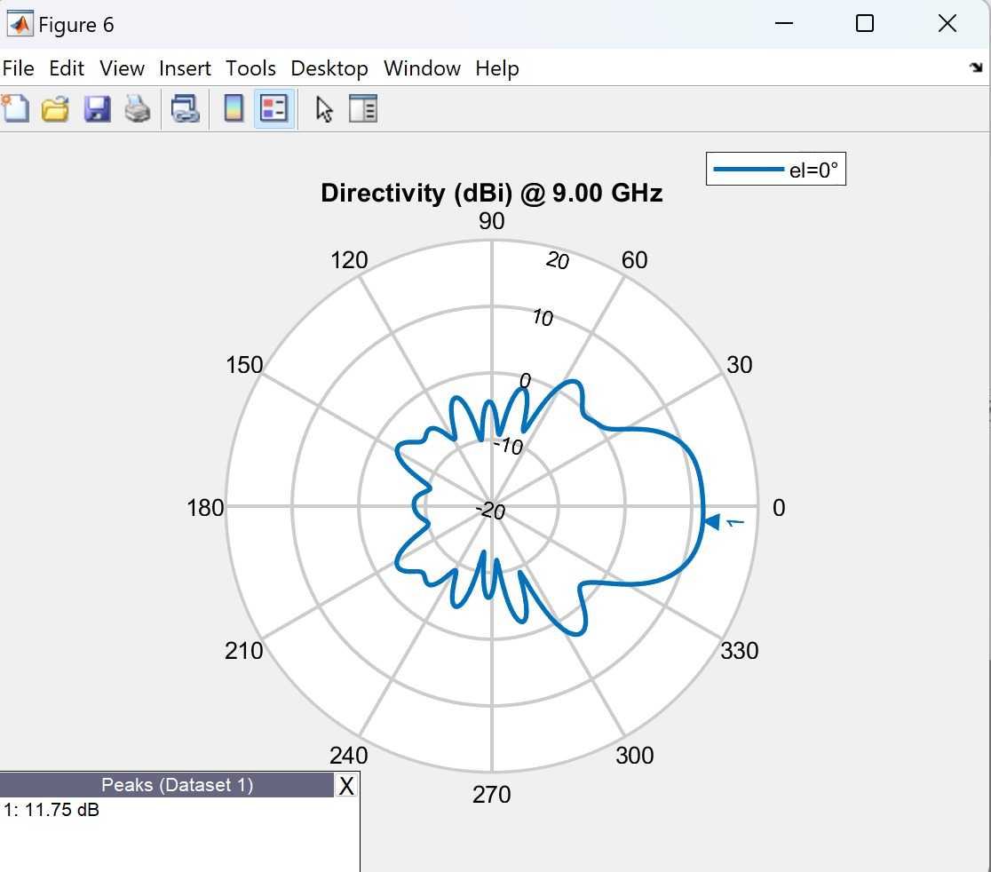

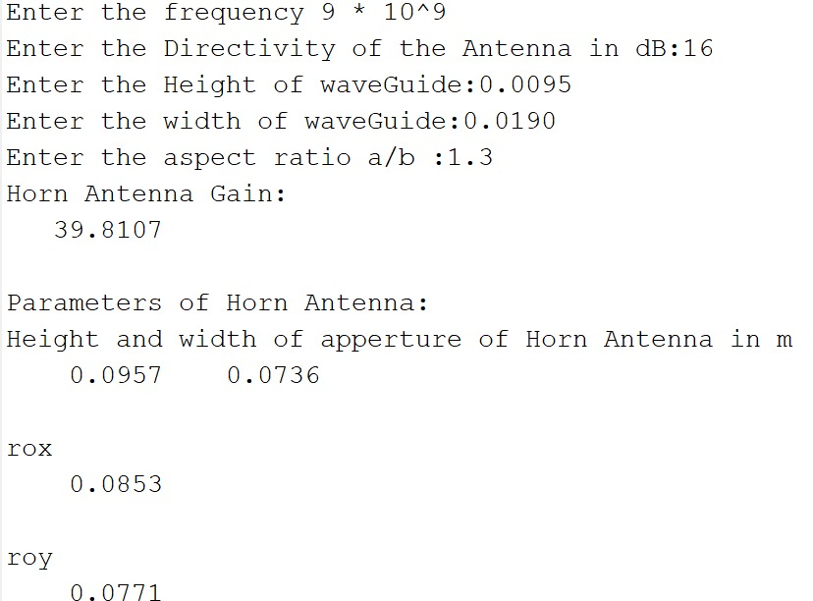

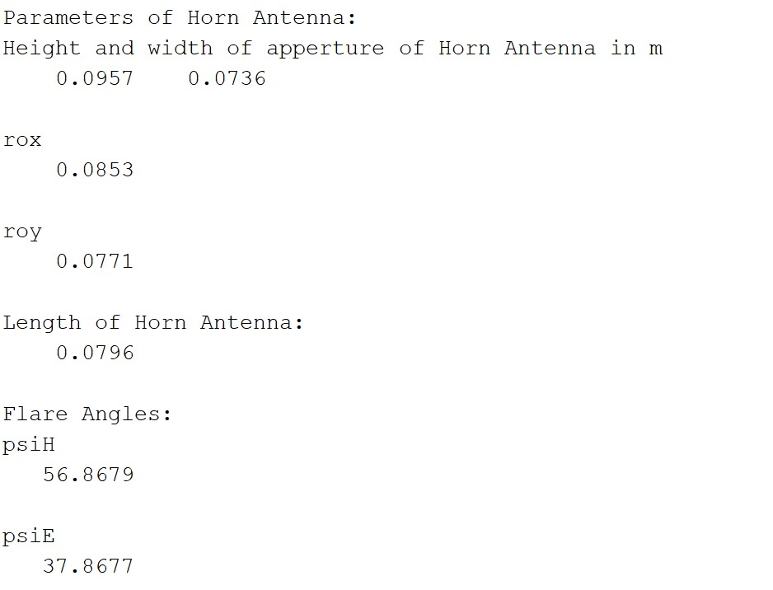

   
 **CHAPTER –5**

**CONCLUSION**

In conclusion, designing a horn antenna in MATLAB is a powerful and efficient approach to create an optimized antenna design that meets the specific requirements of a particular application. MATLAB provides a comprehensive platform for antenna design and simulation, with a rich set of functions and tools that can be used to generate and analyze horn antennas.

By following a systematic design methodology, a designer can calculate the dimensions of the horn antenna based on the desired operating frequency and gain, create a MATLAB script or function to generate the horn geometry, simulate the antenna using MATLAB's antenna toolbox or a third-party software to optimize the design, and finally fabricate the physical antenna and test it for its performance characteristics.

Overall, designing a horn antenna in MATLAB can reduce the time and cost required for the antenna design process, as well as improve the antenna's overall performance, such as high gain, wide bandwidth, and low loss. Therefore, it is a highly recommended approach for any engineer or researcher involved in antenna design and develo

Horn antennas are commonly used in microwave frequencies, including 9 GHz. The application of a horn antenna at 9 GHz frequency can include:

Microwave communication: Horn antennas can be used in point-to-point and point-to-multipoint microwave communication systems operating at 9 GHz frequency. They are often used in satellite communication systems, microwave links, and other wireless communication systems.

Radar systems: Horn antennas are commonly used as the feed elements in radar systems operating at 9 GHz frequency. They can be used in various radar applications, including weather radar, air traffic control radar, and military radar systems.

Scientific research: Horn antennas can also be used in scientific research applications that require precise measurement and characterization of electromagnetic radiation at 9 GHz frequency. This includes radio astronomy, plasma physics, and other scientific fields.

Medical applications: Horn antennas can be used in medical applications such as microwave hyperthermia and microwave ablation, which are used to treat cancerous tumors.

Overall, the horn antenna's ability to efficiently radiate electromagnetic waves at 9 GHz makes it a valuable tool in a wide range of applications.